Chapter 8, Solution 56.

In the circuit of Fig. 8.102, find i(t) for t > 0.

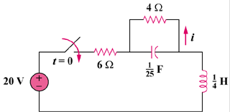

Figure 8.102
For Prob. 8.56.

Solution

For t < 0, i(0) = 0 and v(0) = 0.

For t > 0, the circuit is as shown below.

4 Ω

i

0.25H

0.04F

20

+
−

6 Ω

i

i_{o}

Applying KVL to the larger loop,

-20 +6i_{o} +0.25di_{o}/dt + 25 = 0

Taking the derivative,

6di_{o}/dt + 0.25d²i_{o}/dt² + 25(i_{o} + i) = 0 (1)

For the smaller loop, 4 + 25 = 0

Taking the derivative, 25(i + i_{o}) = 0 or i = -i_{o} (2)

From (1) and (2) 6di_{o}/dt + 0.25d²i_{o}/dt² = 0

This leads to, 0.25s² + 6s = 0 or s_{1,2} = 0, -24

i_{o}(t) = (A + Be^{-24t}) and i_{o}(0) = 0 = A + B or B = -A

As t approaches infinity, i_{o}(∞) = 20/10 = 2 = A, therefore B = -2

Thus, i_{o}(t) = (2 - 2e^{-24t}) = -i(t) or

i(t) = (-2 + 2e^{-24t}) A

